**Implement the merge join transformation on tables**

Step1: Drag two Data grid on panel rename them with Employee and Department respectively.

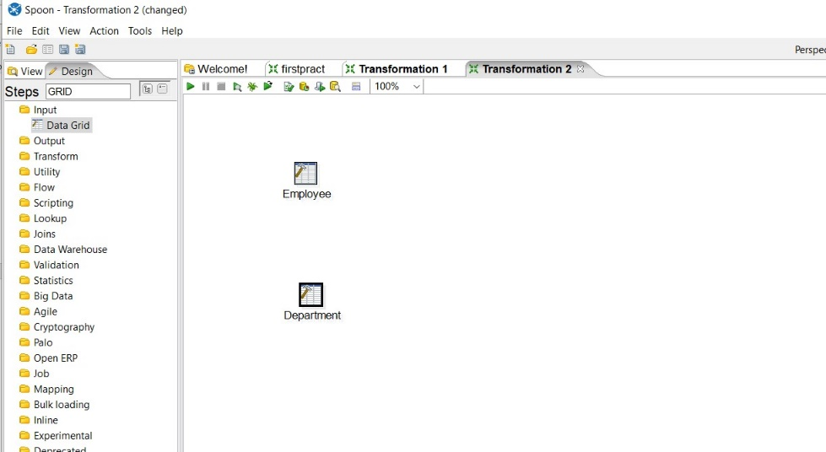

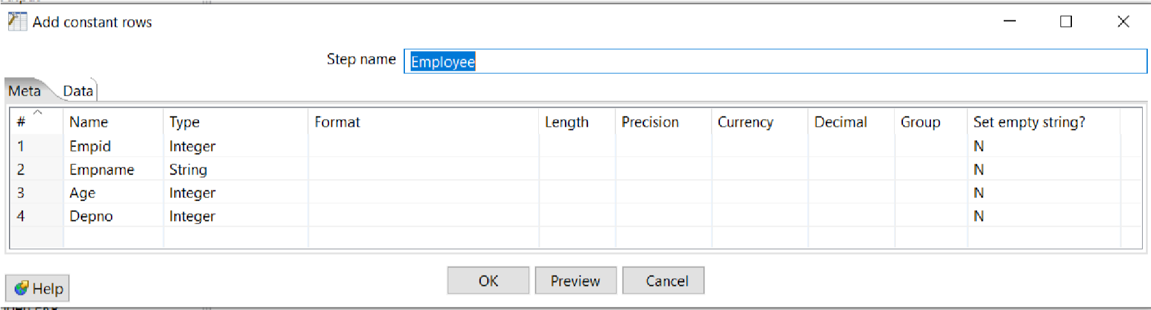**Step2: Insert records into respective grids.**

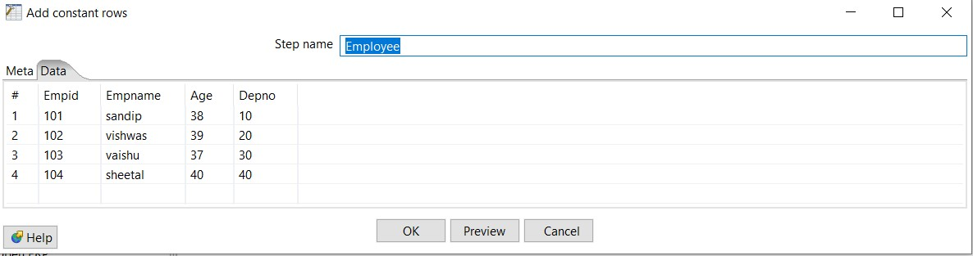

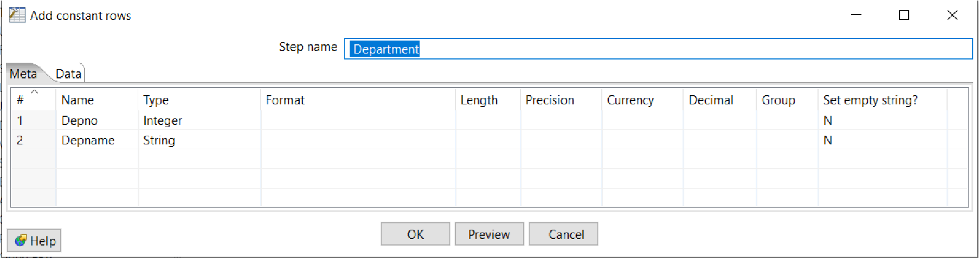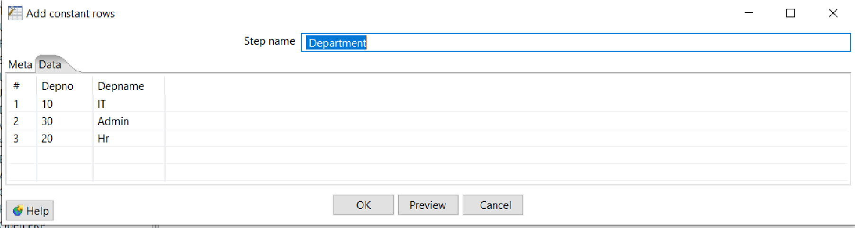

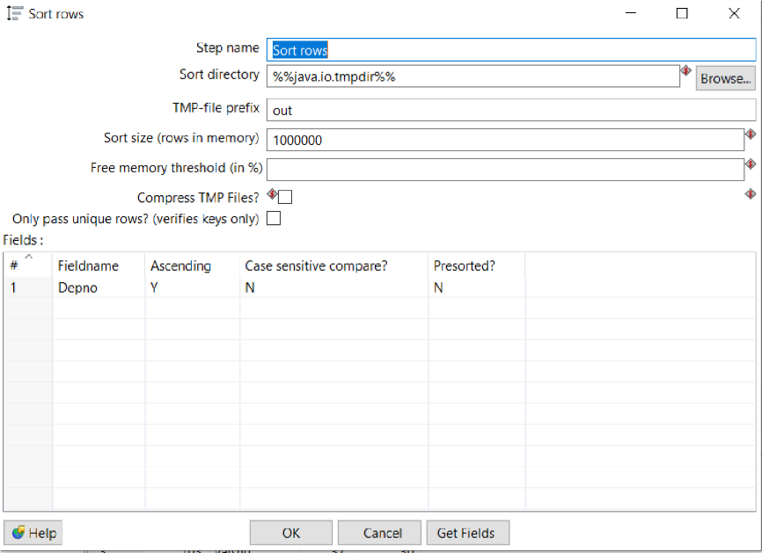Step3: Insert sort rows transformation(on Empid) for both Employee and Department.

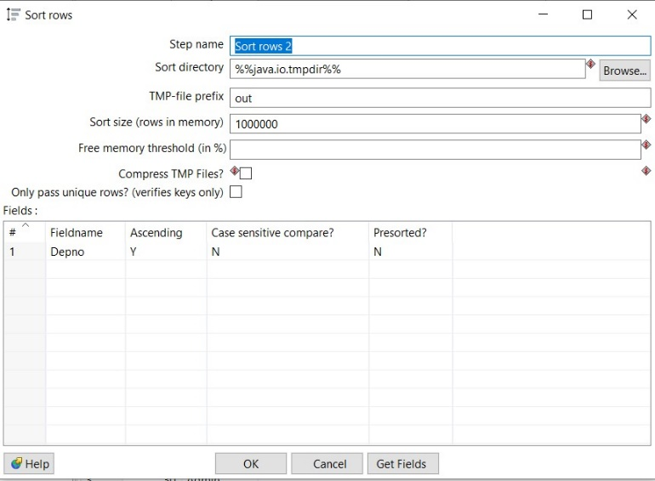

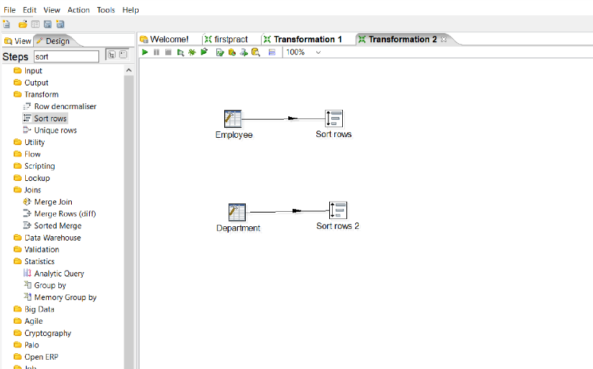

Step4: Add Merge join From Joins and connect it with sort rows.

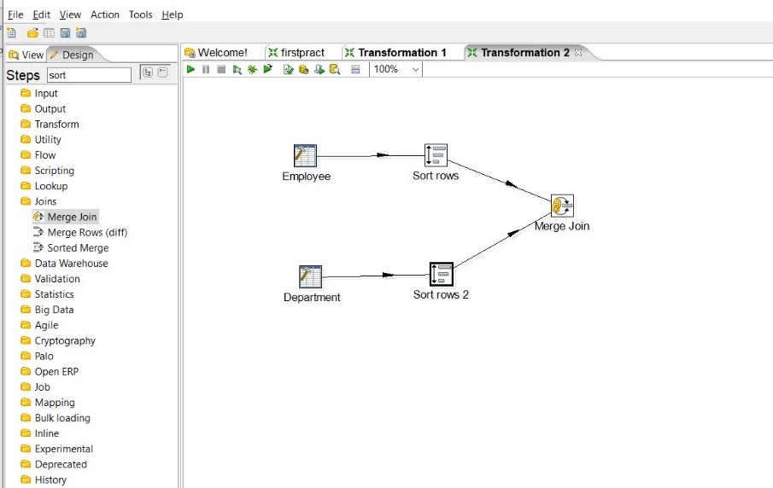

Step5: Double click on Merge join and made necessary settings First select First_step, then Second_step, select Join type INNER, and from get fields select Depno only, after that quick launch the transformation.

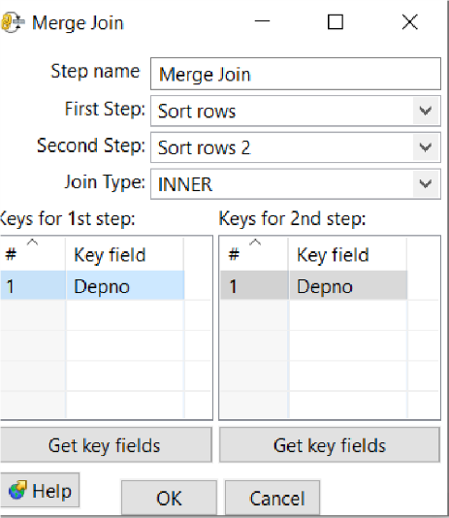

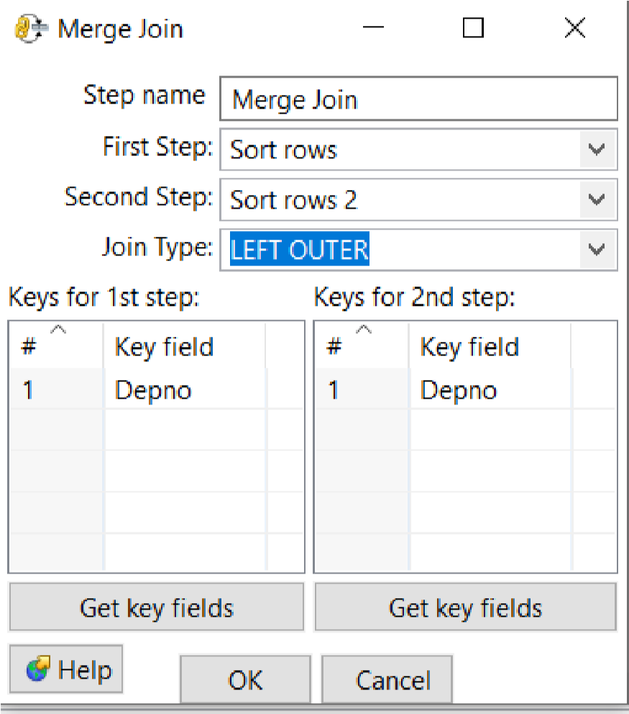 **Step 6: Select Join Type LeftOuter,then Right outer and finally Full outer join**

